The Scarab ship tries to fly into you and explode to do damage when it gets close it explodes after a second.

The Killer bee ship flies in a wave like this and shoots a burst from each gun as it turns to face the middle of the screen.

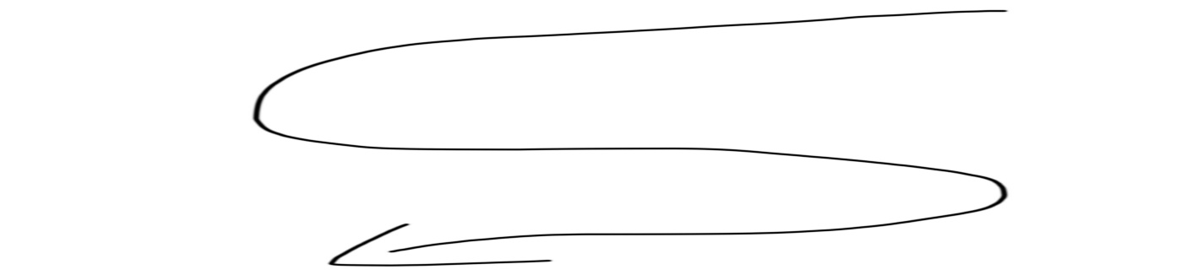

The Wasp ship stays at the top of the screen firing a beam that goes across the screen and then the ship strafes slightly to the left or right for a few seconds then stops and flies straight down .